Parcel 6

1602 River St, City of Olean
No Photo Available |  | Status: | Re-Activated
 |  | Roll Section: | Taxable
 |  | Swis: | 041200
 |  | Tax Map ID #: | 94.033-1-3
 |  | Account #: | 043860
 |  | Property Class: | 311 - Res vac land
 |  | Site: | RES 1
 |  | In Ag. District: | No
 |  | Site Property Class: | 311 - Res vac land
 |  | Zoning Code: | -
 |  | Neighborhood Code: | 12205
Total Acreage/Size: | 31.5 x 64 | School District: | Olean
Land Assessment: | 2016- $2,100 | Total Assessment: | 2016 - $2,100
Full Market Value: | 2016 - $2,283
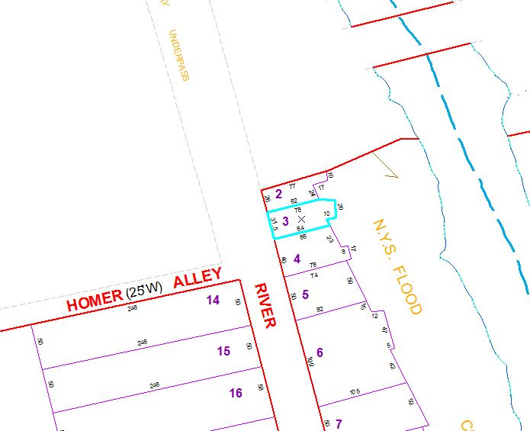
Approximate Yearly Taxes

School $54
City $30
County $29

Total $113

