Parcel 57

518 Prospect Ave, City of Olean
No Photo Available |  | Status: | Active
 |  | Roll Section: | Taxable
 |  | Swis: | 041200
 |  | Tax Map ID #: | 94.058-2-4
 |  | Account #: | 041290
 |  | Property Class: | 311 - Res vac land
 |  | Site: | RES 1
 |  | In Ag. District: | No
 |  | Site Property Class: | 311 - Res vac land
 |  | Zoning Code: | R1
 |  | Neighborhood Code: | 12208
Total Acreage/Size: | 40 x 140.5 | School District: | Olean
Land Assessment: | 2016 - $2,000 | Total Assessment: | 2016 - $2,000
Full Market Value: | 2016 - $2,174

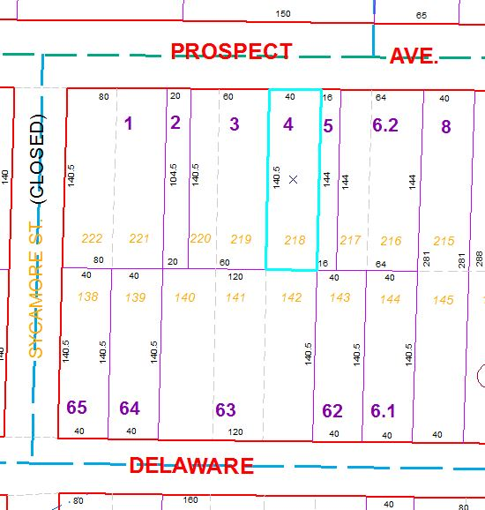
Approximate Yearly Taxes

School $52
City $29
County $28

Total $109

