Parcel 50

122 Henley St E, City of Olean
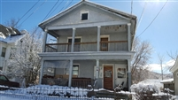 |  |  |  |  |  |  |  |  |  | Status: |  |  |  | Active
 |  |  |  |  |  |  |  |  |  | Roll Section: |  |  |  | Taxable
 |  |  |  |  |  |  |  |  |  | Swis: |  |  |  | 041200
 |  |  |  |  |  |  |  |  |  | Tax Map ID #: |  |  |  | 94.073-4-6
 |  |  |  |  |  |  |  |  |  | Account #: |  |  |  | 024215
 |  |  |  |  |  |  |  |  |  | Property Class: |  |  |  | 411 - Apartment
 |  |  |  |  |  |  |  |  |  | Site: |  |  |  | COM 1
 |  |  |  |  |  |  |  |  |  | In Ag. District: |  |  |  | No
 |  |  |  |  |  |  |  |  |  | Site Property Class: |  |  |  | 411 - Apartment
 |  |  |  |  |  |  |  |  |  | Zoning Code: |  |  |  | -
 |  |  |  |  |  |  |  |  |  | Neighborhood Code: |  |  |  | 12402
Total Acreage/Size: |  |  |  |  | 40.9 x 100 |  |  |  |  | School District: |  |  |  | Olean
Land Assessment: |  |  |  |  | 2016 - $4,500 |  |  |  |  | Total Assessment: |  |  |  | 2016 - $61,000
Full Market Value: |  |  |  |  | 2016 - $66,304
AC% | Sprinkler% | Alarm% |  | Elevators |  |  | Basement Type | Year Built |  |  | Condition | Quality |  |  | Gross Floor Area (sqft) |  | Stories
0 | 0 | 0 |  | 0 |  |  | Unfinished | 1910 |  |  | Normal | Average |  |  | 2660 |  | 2.00
Structure |  |  | Size |  |  | Grade |  |  | Condition |  |  |  | Year
Porch-up covered |  |  | 25 × 8 |  |  | Average |  |  | Normal |  |  |  | 1910
Porch-covered |  |  | 25 × 8 |  |  | Average |  |  | Normal |  |  |  | 1910
Porch-enclosed |  |  | 25 × 8 |  |  | Average |  |  | Normal |  |  |  | 1910
Porch-up enclosed |  |  | 25 × 8 |  |  | Average |  |  | Normal |  |  |  | 1910
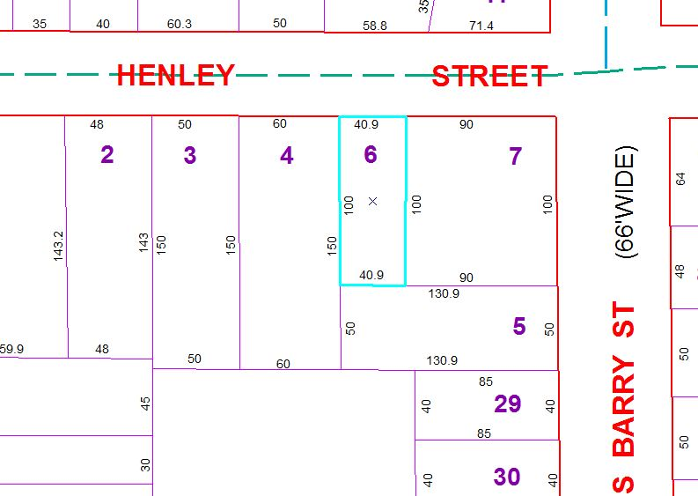
Approximate Yearly Taxes

School $1,563
City $880
County $833

Total $3,276

