Parcel 402

10882 Eastland Rd, Town of Yorkshire
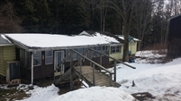 |  | Status: | Active
 |  | Roll Section: | Taxable
 |  | Swis: | 048489
 |  | Tax Map ID #: | 12.001-2-47
 |  | Account #: | 1113
 |  | Property Class: | 270 - Mfg housing
 |  | Site: | NOSITE 0
 |  | In Ag. District: | No
 |  | Site Property Class: | N/A
 |  | Zoning Code: | N/A
 |  | Neighborhood Code: | N/A
Total Acreage/Size: | 2.43 | School District: | Yorkshire-Pioneer
Land Assessment: | 2016 - $3,100 | Total Assessment: | 2016 - $14,340
Full Market Value: | 2016 - $86,909 | Approximate Yearly Taxes  School $1,142  Town/County $1,483  Total $2,625

