Parcel 374

9 Borden St, Town of Randolph
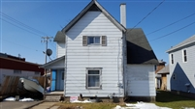 |  |  |  |  |  | Status: |  |  | Active
 |  |  |  |  |  | Roll Section: |  |  | Taxable
 |  |  |  |  |  | Swis: |  |  | 047600
 |  |  |  |  |  | Tax Map ID #: |  |  | 70.063-3-11
 |  |  |  |  |  | Account #: |  |  | 0815
 |  |  |  |  |  | Property Class: |  |  | 210 - 1 Family Res
 |  |  |  |  |  | Site: |  |  | RES 1
 |  |  |  |  |  | In Ag. District: |  |  | No
 |  |  |  |  |  | Site Property Class: |  |  | 210 - 1 Family Res
 |  |  |  |  |  | Zoning Code: |  |  | R-1
 |  |  |  |  |  | Neighborhood Code: |  |  | 76010
Total Acreage/Size: |  | 48 x 107 |  |  |  | School District: |  |  | Randolph
Land Assessment: |  | 2016 - $3,300 |  |  |  | Total Assessment: |  |  | 2016 - $43,000
Full Market Value: |  | 2016 - $53,086
Living Area: | 1,374 sq. ft. |  |  | First Story Area: |  |  | 694 sq. ft.
Second Story Area: | 586 sq. ft. |  |  | Half Story Area: |  |  | 94 sq. ft.
Finished Basement: | 0 sq. ft. |  |  | Number of Stories: |  |  | 2
Building Style: | Old style |  |  | Bathrooms Full - Half: |  |  | 1 - 0
Bedrooms: | 3 |  |  | Kitchens: |  |  | 1
Fireplaces: | 0 |  |  | Basement Type: |  |  | Partial
Porch Type: | Porch-enclosed |  |  | Porch Area: |  |  | 98.00
Overall Condition: | Normal |  |  | Overall Grade: |  |  | Average
Year Built: | 1940
Structure | Size |  | Grade |  | Condition |  |  | Year
Porch-enclosed | 7 × 14 |  | Average |  | Normal |  |  | 1930
Porch-enclosed | 9 × 9 |  | Average |  | Normal |  |  | 1930
Porch-covered | 66 sq. ft. |  | Average |  | Normal |  |  | 1940

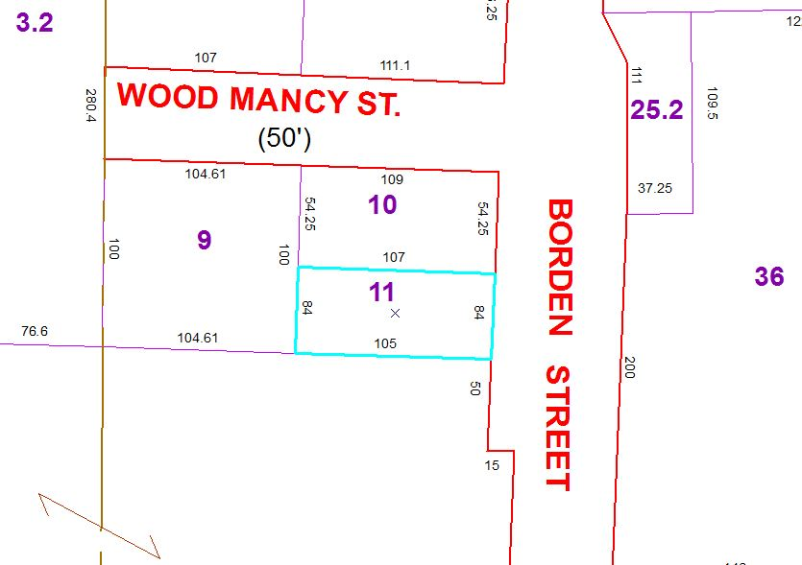
Approximate Yearly Taxes

School $ 572
Town/County $1,196

Total $1,768

