Parcel 331

35 Commercial St, V. Gowanda
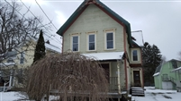 |  |  |  |  |  | Status: |  |  |  | Active
 |  |  |  |  |  | Roll Section: |  |  |  | Taxable
 |  |  |  |  |  | Swis: |  |  |  | 047201
 |  |  |  |  |  | Tax Map ID #: |  |  |  | 16.028-1-15
 |  |  |  |  |  | Account #: |  |  |  | 0282
 |  |  |  |  |  | Property Class: |  |  |  | 220 - 2 Family Res
 |  |  |  |  |  | Site: |  |  |  | RES 1
 |  |  |  |  |  | In Ag. District: |  |  |  | No
 |  |  |  |  |  | Site Property Class: |  |  |  | 220 - 2 Family Res
 |  |  |  |  |  | Zoning Code: |  |  |  | -
 |  |  |  |  |  | Neighborhood Code: |  |  |  | 72080
Total Acreage/Size: |  |  | 37 x 176 |  |  | School District: |  |  |  | Gowanda
Land Assessment: |  |  | 2016 - $3,500 |  |  | Total Assessment: |  |  |  | 2016 - $40,500
Full Market Value: |  |  | 2016 - $52,597
Living Area: |  | 2,094 sq. ft. |  |  | First Story Area: |  |  | 1,047 sq. ft.
Second Story Area: |  | 1,047 sq. ft. |  |  | Half Story Area: |  |  | 0 sq. ft.
Finished Basement: |  | 0 sq. ft. |  |  | Number of Stories: |  |  | 2
Building Style: |  | Old style |  |  | Bathrooms Full - Half: |  |  | 2 - 0
Bedrooms: |  | 6 |  |  | Kitchens: |  |  | 2
Fireplaces: |  | 0 |  |  | Basement Type: |  |  | Full
Porch Type: |  | Porch-covered |  |  | Porch Area: |  |  | 132.00
Overall Condition: |  | Fair |  |  | Overall Grade: |  |  | Average
Year Built: |  | 1900
Structure | Size |  |  | Grade |  |  | Condition |  | Year
Porch-covered | 11 × 12 |  |  | Average |  |  | Fair |  | 1900
Gar-1.0 detached | 22 × 22 |  |  | Average |  |  | Fair |  | 1920
Gar-1.0 detached | 20 × 20 |  |  | Average |  |  | Fair |  | 1920
Porch-covered | 288 sq. ft. |  |  | Average |  |  | Fair |  | 1900
Porch-enclosed | 0 x 0 |  |  | Average |  |  | Normal |  | 1900
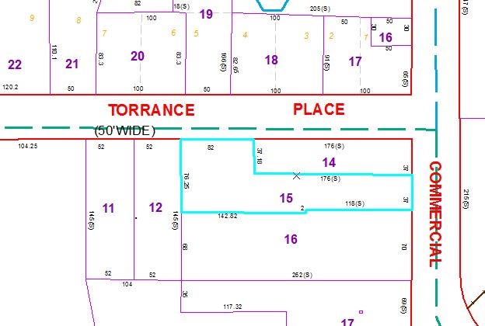
Approximate Yearly Taxes

School $ 960
Village $ 676
Town/County $ 846

Total $2,482

