Parcel 326

11014 North Rd, Town of Perrysburg
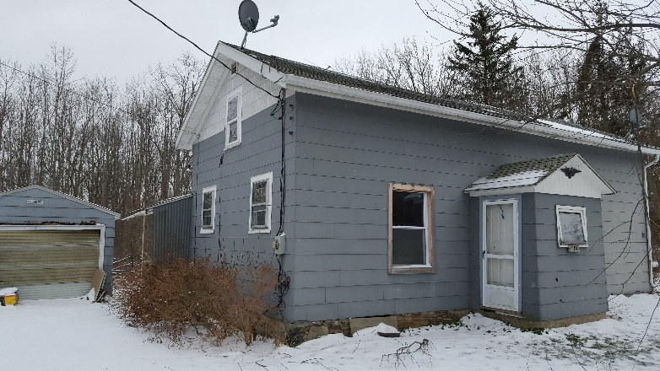 |  |  | Status: |  | Active
 |  |  | Roll Section: |  | Taxable
 |  |  | Swis: |  | 047000
 |  |  | Tax Map ID #: |  | 8.001-1-15.2
 |  |  | Account #: |  | 0833
 |  |  | Property Class: |  | 210 - 1 Family Res
 |  |  | Site: |  | RES 1
 |  |  | In Ag. District: |  | No
 |  |  | Site Property Class: |  | 210 - 1 Family Res
 |  |  | Zoning Code: |  | AR40
 |  |  | Neighborhood Code: |  | 70350
Total Acreage/Size: | 5.50 |  | School District: |  | Gowanda
Land Assessment: | 2016 - $11,500 |  | Total Assessment: |  | 2016 - $38,600
Full Market Value: | 2016 - $54,366
Living Area: | 1,377 sq. ft. |  | First Story Area: |  | 918 sq. ft.
Second Story Area: | 0 sq. ft. |  | Half Story Area: |  | 459 sq. ft.
Finished Basement: | 0 sq. ft. |  | Number of Stories: |  | 1.5
Building Style: | Old style |  | Bathrooms Full – Half: |  | 1 - 0
Bedrooms: | 3 |  | Kitchens: |  | 1
Fireplaces: | 0 |  | Basement Type: |  | Full
Porch Type: | Porch-covered |  | Porch Area: |  | 24.00
Overall Condition: | Normal |  | Overall Grade: |  | Average
Year Built: | 1850
Structure | Size | Grade |  | Condition |  | Year
Gar-1.0 detached | 14 × 24 | Average |  | Normal |  | 1980
Porch-covered | 4 × 6 | Average |  | Normal |  | 1960
Porch-enclosed | 5 × 7 | Average |  | Normal |  | 1990
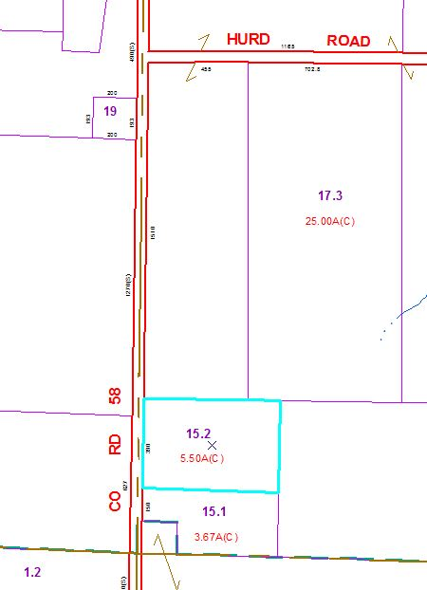
Approximate Yearly Taxes

School $ 993
Town/County $1,055

Total $2,048

