Parcel 325

11008 North Rd, Town of Perrysburg
No Photo Available |  |  | Status: |  | Active
 |  |  | Roll Section: |  | Taxable
 |  |  | Swis: |  | 047000
 |  |  | Tax Map ID #: |  | 8.001-1-15.1
 |  |  | Account #: |  | 0409
 |  |  | Property Class: |  | 312 - Vac w/imprv
 |  |  | Site: |  | RES 1
 |  |  | In Ag. District: |  | No
 |  |  | Site Property Class: |  | 312 - Vac w/imprv
 |  |  | Zoning Code: |  | AR20
 |  |  | Neighborhood Code: |  | 70350
Total Acreage/Size: | 3.67 |  | School District: |  | Gowanda
Land Assessment: | 2016 - $9,000 |  | Total Assessment: |  | 2016 - $14,700
Full Market Value: | 2016 - $20,704
Structure | Size | Grade |  | Condition |  | Year
Gar-1.0 detached | 18 × 24 | Average |  | Normal |  | 1988

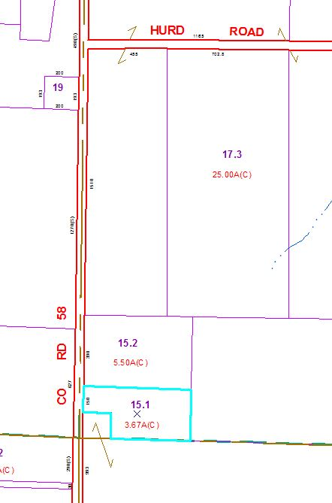
Approximate Yearly Taxes

School $378
Town/County $402

Total $780

