Parcel 31

105 Thirteenth St S, City of Olean
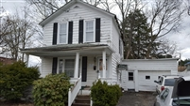 |  |  |  |  |  |  |  | Status: |  |  | Active
 |  |  |  |  |  |  |  | Roll Section: |  |  | Taxable
 |  |  |  |  |  |  |  | Swis: |  |  | 041200
 |  |  |  |  |  |  |  | Tax Map ID #: |  |  | 94.064-10-62
 |  |  |  |  |  |  |  | Account #: |  |  | 057750
 |  |  |  |  |  |  |  | Property Class: |  |  | 210 - 1 Family Res
 |  |  |  |  |  |  |  | Site: |  |  | RES 1
 |  |  |  |  |  |  |  | In Ag. District: |  |  | No
 |  |  |  |  |  |  |  | Site Property Class: |  |  | 210 - 1 Family Res
 |  |  |  |  |  |  |  | Zoning Code: |  |  | -
 |  |  |  |  |  |  |  | Neighborhood Code: |  |  | 12206
Total Acreage/Size: |  |  |  | 40 x 42 |  |  |  | School District: |  |  | Olean
Land Assessment: |  |  |  | 2016 - $1,000 |  |  |  | Total Assessment: |  |  | 2016 - $48,000
Full Market Value: |  |  |  | 2016 - $52,174
Living Area: |  |  | 1,080 sq. ft. |  |  | First Story Area: |  |  |  | 612 sq. ft.
Second Story Area: |  |  | 468 sq. ft. |  |  | Half Story Area: |  |  |  | 0 sq. ft.
Finished Basement: |  |  | 0 sq. ft. |  |  | Number of Stories: |  |  |  | 2
Building Style: |  |  | Old style |  |  | Bathrooms (Full - Half): |  |  |  | 1 - 0
Bedrooms: |  |  | 2 |  |  | Kitchens: |  |  |  | 1
Fireplaces: |  |  | 0 |  |  | Basement Type: |  |  |  | Partial
Porch Type: |  |  | Porch-covered |  |  | Porch Area: |  |  |  | 108.00
Basement Garage Cap: |  |  | 0 |  |  | Attached Garage Cap: |  |  |  | 340.00 sq. ft.
Overall Condition: |  |  | Normal |  |  | Overall Grade: |  |  |  | Average
Year Built: |  |  | 1900
Structure | Size |  |  |  | Grade |  | Condition |  | Year
Porch-covered |  | 6 × 18 |  |  | Average |  | Normal |  | 1900
Porch-enclosed |  | 6 × 12 |  |  | Average |  | Normal |  | 1900
Gar-1.0 attached |  | 17 × 20 |  |  | Average |  | Normal |  | 1930
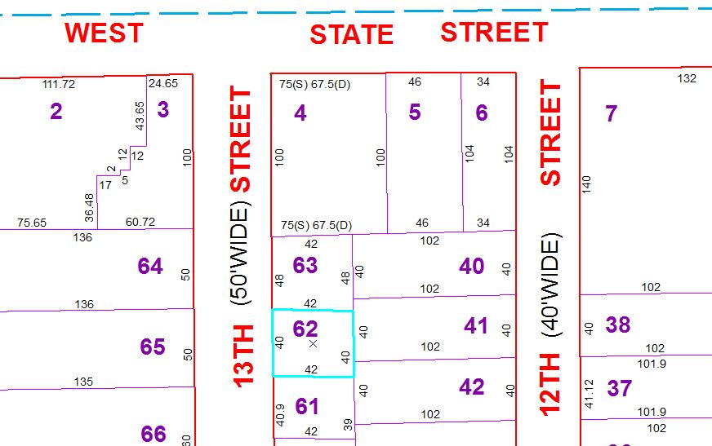
Approximate Yearly Taxes

School $1,230
City $ 693
County $ 655

Total $2,578

