Parcel 303

2640 Swarts Rd, Town of Olean
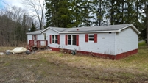 |  |  |  |  |  | Status: |  |  | Active
 |  |  |  |  |  | Roll Section: |  |  | Taxable
 |  |  |  |  |  | Swis: |  |  | 046600
 |  |  |  |  |  | Tax Map ID #: |  |  | 103.003-2-22
 |  |  |  |  |  | Account #: |  |  | 0401
 |  |  |  |  |  | Property Class: |  |  | 281 - Multiple res
 |  |  |  |  |  | Site: |  |  | RES 1
 |  |  |  |  |  | In Ag. District: |  |  | No
 |  |  |  |  |  | Site Property Class: |  |  | 281 - Multiple res
 |  |  |  |  |  | Zoning Code: |  |  | -
 |  |  |  |  |  | Neighborhood Code: |  |  | 66350
Total Acreage/Size: |  | 1.64 |  |  |  | School District: |  |  | Olean
Land Assessment: |  | 2016 - $4,400 |  |  |  | Total Assessment: |  |  | 2016 - $51,900
Full Market Value: |  | 2016 - $66,538
Living Area: | 1,440 sq. ft. |  |  | First Story Area: |  |  | 1,440 sq. ft.
Finished Basement: | 0 sq. ft. |  |  | Number of Stories: |  |  | 1
Building Style: | Ranch |  |  | Bathrooms Full - Half: |  |  | 2 - 0
Bedrooms: | 3 |  |  | Kitchens: |  |  | 1
Fireplaces: | 0 |  |  | Basement Type: |  |  | Slab/pier
Porch Type: | Porch-covered |  |  | Porch Area: |  |  | 32.00
Overall Condition: | Fair |  |  | Overall Grade: |  |  | Economy
Year Built: | 1993
Structure | Size |  | Grade |  | Condition |  |  | Year
Mh:wood add | 12 × 8 |  | Economy |  | Fair |  |  | 1982
Gar-1.0 detached | 40 × 42 |  | Economy |  | Fair |  |  | 1982
Mobile home | 70 × 14 |  | Economy |  | Fair |  |  | 1982
Porch-covered | 8 × 4 |  | Economy |  | Fair |  |  | 1982
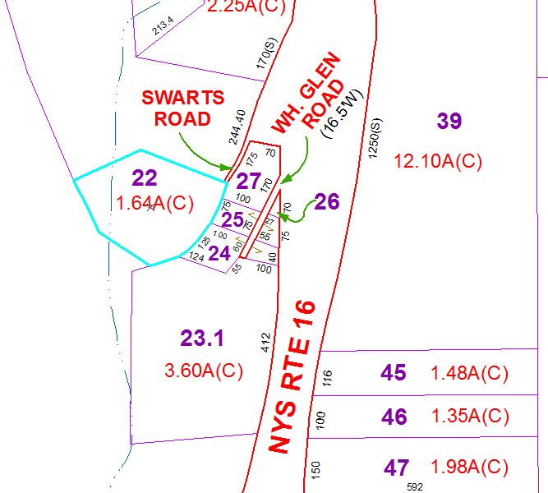
Approximate Yearly Taxes

School $1,620
Town/County $1,163

Total $2,783

