Parcel 295

74 South St, V. Cattaraugus
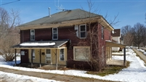 |  |  |  |  |  |  | Status: |  |  |  | Active
 |  |  |  |  |  |  | Roll Section: |  |  |  | Taxable
 |  |  |  |  |  |  | Swis: |  |  |  | 046401
 |  |  |  |  |  |  | Tax Map ID #: |  |  |  | 35.082-5-16
 |  |  |  |  |  |  | Account #: |  |  |  | 0585
 |  |  |  |  |  |  | Property Class: |  |  |  | 210 - 1 Family Res
 |  |  |  |  |  |  | Site: |  |  |  | RES 1
 |  |  |  |  |  |  | In Ag. District: |  |  |  | No
 |  |  |  |  |  |  | Site Property Class: |  |  |  | 210 - 1 Family Res
 |  |  |  |  |  |  | Zoning Code: |  |  |  | -
 |  |  |  |  |  |  | Neighborhood Code: |  |  |  | 00000
Total Acreage/Size: |  |  | 66 x 90.75 |  |  |  | School District: |  |  |  | Cattaraugus - Little Valley
Land Assessment: |  |  | 2016 - $1,900 |  |  |  | Total Assessment: |  |  |  | 2016 - $30,000
Full Market Value: |  |  | 2016 - $42,254
Living Area: |  | 2,160 sq. ft. |  |  | First Story Area: |  |  |  |  | 1,080 sq. ft.
Second Story Area: |  | 1,080 sq. ft. |  |  | Number of Stories: |  |  |  |  | 2
Building Style: |  | Old style |  |  | Bathrooms Full - Half: |  |  |  |  | 1 - 0
Bedrooms: |  | 4 |  |  | Kitchens: |  |  |  |  | 1
Fireplaces: |  | 0 |  |  | Basement Type: |  |  |  |  | Partial
Porch Type: |  | Porch-covered |  |  | Porch Area: |  |  |  |  | 192.00
Overall Condition: |  | Fair |  |  | Overall Grade: |  |  |  |  | Average
Year Built: |  | 1910
Structure |  | Size |  |  | Grade |  |  | Condition
Porch-covered | 8 × 24 |  |  | Average |  | Fair |  |  | Year
Porch-covered | 8 × 18 |  |  | Average |  | Fair |  |  | 1910

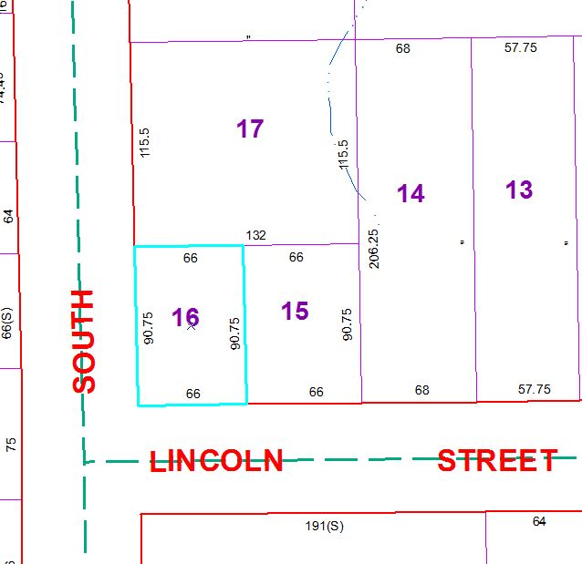
Approximate Yearly Taxes

School $ 643
Village $ 583
Town/County $ 782

Total $2,008

