Parcel 290

135 Waverly St, V. Cattaraugus
No Photo Available |  |  |  | Status: |  | Active
 |  |  |  | Roll Section: |  | Taxable
 |  |  |  | Swis: |  | 046401
 |  |  |  | Tax Map ID #: |  | 35.082-3-13
 |  |  |  | Account #: |  | 0858
 |  |  |  | Property Class: |  | 311 - Res vac land
 |  |  |  | Site: |  | RES 1
 |  |  |  | In Ag. District: |  | No
 |  |  |  | Site Property Class: |  | 311 - Res vac land
 |  |  |  | Zoning Code: |  | -
 |  |  |  | Neighborhood Code: |  | 00000
Total Acreage/Size: |  | 57 x 180.3 |  | School District: |  | Cattaraugus - Little Valley
Land Assessment: |  | 2016 - $2,200 |  | Total Assessment: |  | 2016 - $2,200
Full Market Value: |  | 2016 - $3,099
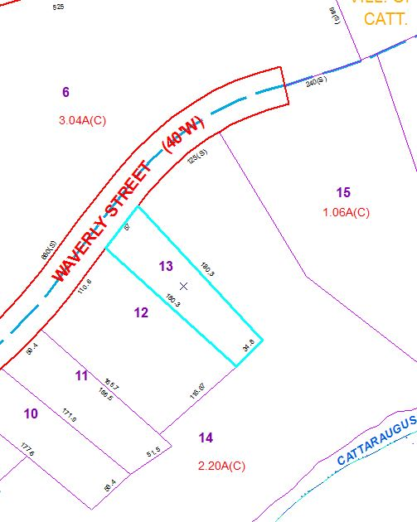
Approximate Yearly Taxes

School $ 48
Village $ 43
Town/County $ 58

Total $149

