Parcel 286

9339 Pigeon Valley Rd, Town of New Albion
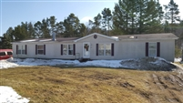 |  |  |  |  | Status: |  | Active
 |  |  |  |  | Roll Section: |  | Taxable
 |  |  |  |  | Swis: |  | 046489
 |  |  |  |  | Tax Map ID #: |  | 53.002-2-24.2
 |  |  |  |  | Account #: |  | 1082
 |  |  |  |  | Property Class: |  | 270 - Mfg housing
 |  |  |  |  | Site: |  | RES 1
 |  |  |  |  | In Ag. District: |  | No
 |  |  |  |  | Site Property Class: |  | 270 - Mfg housing
 |  |  |  |  | Zoning Code: |  | -
 |  |  |  |  | Neighborhood Code: |  | 64350
Total Acreage/Size: |  | 180 x 254 |  |  | School District: |  | Cattaraugus - Little Valley
Land Assessment: |  | 2016 - $4,600 |  |  | Total Assessment: |  | 2016 - $56,000
Full Market Value: |  | 2016 - $78,873
Structure | Size |  | Grade | Condition |  | Year
Shed-machine | 22 × 12 |  | Average | Normal |  | 1972
Shed-machine | 12 × 12 |  | Average | Normal |  | 1972
Mobile home | 76 × 28 |  | Average | Normal |  | 2004
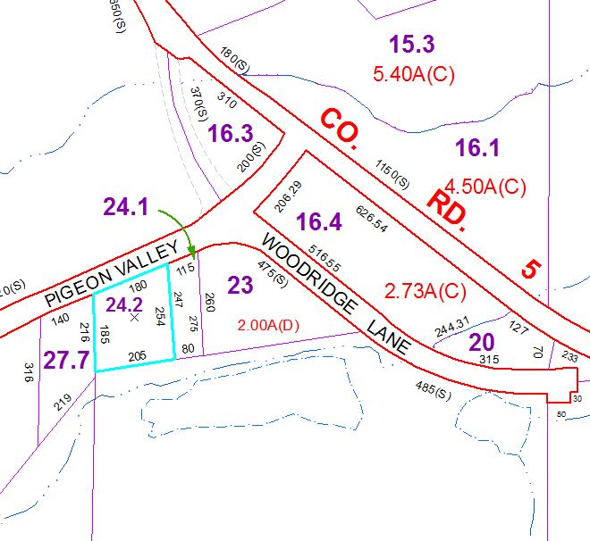
Approximate Yearly Taxes

School $1,199
Town/County $1,651

Total $2,850

