Parcel 285

35 Main St N, V. Cattaraugus
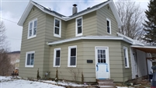 |  |  |  |  |  | Status: |  |  |  | Active
 |  |  |  |  |  | Roll Section: |  |  |  | Taxable
 |  |  |  |  |  | Swis: |  |  |  | 046401
 |  |  |  |  |  | Tax Map ID #: |  |  |  | 35.081-1-13
 |  |  |  |  |  | Account #: |  |  |  | 0646
 |  |  |  |  |  | Property Class: |  |  |  | 210 - 1 Family Res
 |  |  |  |  |  | Site: |  |  |  | RES 1
 |  |  |  |  |  | In Ag. District: |  |  |  | No
 |  |  |  |  |  | Site Property Class: |  |  |  | 210 - 1 Family Res
 |  |  |  |  |  | Zoning Code: |  |  |  | -
Total Acreage/Size: |  | 1.30 |  |  |  | School District: |  |  |  | Cattaraugus - Little Valley
Land Assessment: |  | 2016 - $8,200 |  |  |  | Total Assessment: |  |  |  | 2016 - $25,000
Full Market Value: |  | 2016 - $35,211
Living Area: | 1,516 sq. ft. |  |  | First Story Area: |  |  |  |  | 928 sq. ft.
Second Story Area: | 588 sq. ft. |  |  | Half Story Area: |  |  |  |  | 0 sq. ft.
Finished Basement: | 0 sq. ft. |  |  | Number of Stories: |  |  |  |  | 2
Building Style: | Old style |  |  | Bathrooms (Full - Half): |  |  |  |  | 1 - 1
Bedrooms: | 3 |  |  | Kitchens: |  |  |  |  | 1
Fireplaces: | 0 |  |  | Basement Type: |  |  |  |  | Partial
Porch Type: | Porch-enclosed |  |  | Porch Area: |  |  |  |  | 160.00
Overall Condition: | Fair |  |  | Overall Grade: |  |  |  |  | Average
Year Built: | 1900
Structure | Size |  | Grade |  | Condition |  |  | Year
Porch-enclosed | 8 × 20 |  | Average |  | Normal |  |  | 1900
Porch-open/deck | 24 × 10 |  | Average |  | Normal |  |  | 1900
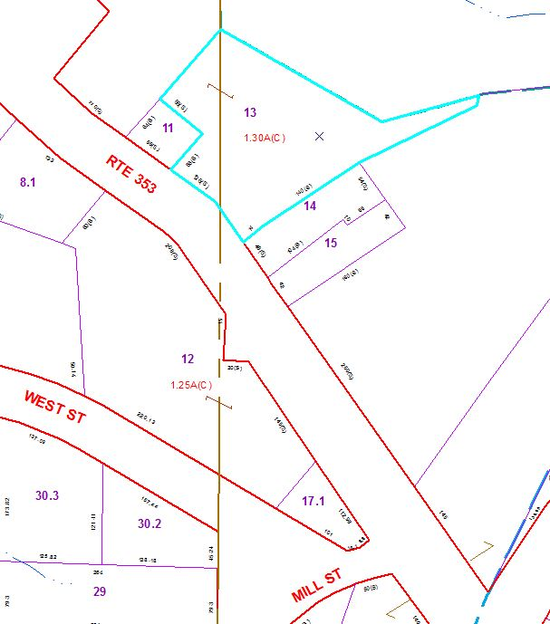
Approximate Yearly Taxes

School $ 535
Village $ 487
Town/County $ 652

Total $1,674

