Parcel 284

6779 NYS Rte 353, Town of New Albion
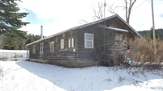 |  |  |  |  |  |  | Status: |  |  | Active
 |  |  |  |  |  |  | Roll Section: |  |  | Taxable
 |  |  |  |  |  |  | Swis: |  |  | 046489
 |  |  |  |  |  |  | Tax Map ID #: |  |  | 44.004-2-19.2
 |  |  |  |  |  |  | Account #: |  |  | 1081
 |  |  |  |  |  |  | Property Class: |  |  | 270 – Mfg. housing
 |  |  |  |  |  |  | Site: |  |  | RES 1
 |  |  |  |  |  |  | In Ag. District: |  |  | No
 |  |  |  |  |  |  | Site Property Class: |  |  | 270 – Mfg. housing
 |  |  |  |  |  |  | Zoning Code: |  |  | -
 |  |  |  |  |  |  | Neighborhood Code: |  |  | 64350
Total Acreage/Size: |  |  | 6.70 |  |  |  | School District: |  |  | Cattaraugus - Little Valley
Land Assessment: |  |  | 2016 - $8,800 |  |  |  | Total Assessment: |  |  | 2016 - $20,000
Full Market Value: |  |  | 2016 - $28,169
Porch Type: |  | Porch-covered |  |  | Porch Area: |  |  | 240.00
Structure |  | Size |  |  | Grade |  |  | Condition
Porch-covered | 24 × 10 |  |  | Economy |  | Fair |  |  | Year
Mobile home | 56 × 34 |  |  | Economy |  | Fair |  |  | 1972
Shed-machine | 10 × 8 |  |  | Average |  | Normal |  |  | 1972
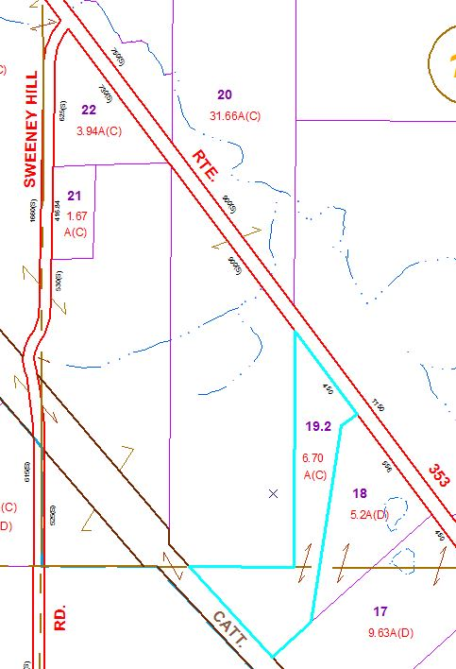
Approximate Yearly Taxes

School $ 429
Town/County $ 589

Total $1,018

