Parcel 280

10 Summervale Dr., Town of Napoli
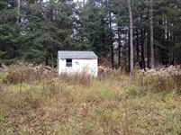 |  |  |  | Status: |  | Active
 |  |  |  | Roll Section: |  | Taxable
 |  |  |  | Swis: |  | 046200
 |  |  |  | Tax Map ID #: |  | 62.039-1-11
 |  |  |  | Account #: |  | 0965
 |  |  |  | Property Class: |  | 312 - Vac w/imprv.
 |  |  |  | Site: |  | RES 1
 |  |  |  | In Ag. District: |  | No
 |  |  |  | Site Property Class: |  | 312 - Vac w/imprv.
 |  |  |  | Zoning Code: |  | -
 |  |  |  | Neighborhood Code: |  | 62030
Total Acreage/Size: |  | 75 x 150 |  | School District: |  | Cattaraugus - Little Valley
Land Assessment: |  | 2016 - $800 |  | Total Assessment: |  | 2016 - $4,000
Full Market Value: |  | 2016 - $4,000
Structure | Size |  | Grade |  | Condition |  | Year
Shed-machine | 15 × 15 |  | Average |  | Normal |  | 1990
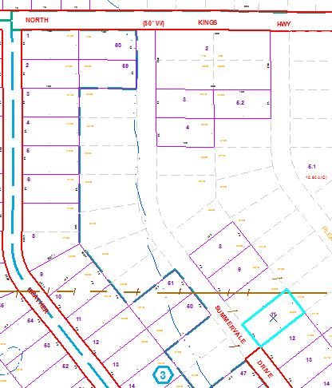
Approximate Yearly Taxes

School $ 62
Town/County $ 81

Total $143

