Parcel 278

Enchanted Lake, Town of Napoli
No Photo Available |  | Status: | Active
 |  | Roll Section: | Taxable
 |  | Swis: | 046200
 |  | Tax Map ID #: | 62.070-6-54
 |  | Account #: | 0406
 |  | Property Class: | 314 - Rural vac<10
 |  | Site: | RES 1
 |  | In Ag. District: | No
 |  | Site Property Class: | 314 - Rural vac<10
 |  | Zoning Code: | -
 |  | Neighborhood Code: | 62030
Total Acreage/Size: | 25 x 87 | School District: | Randolph
Land Assessment: | 2016 - $200 | Total Assessment: | 2016 - $200
Full Market Value: | 2016 - $200
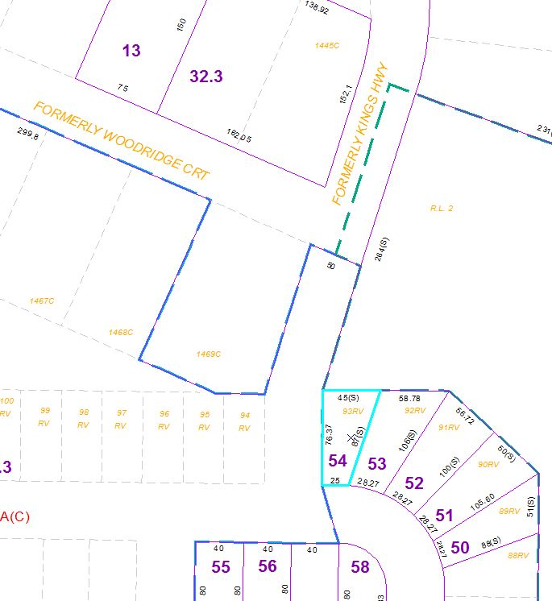
Approximate Yearly Taxes

School $3
Town/County $4

Total $7

