Parcel 26

306 Eleventh St N, City of Olean
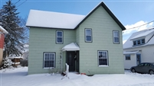 |  |  |  |  |  |  | Status: |  |  | Active
 |  |  |  |  |  |  | Roll Section: |  |  | Taxable
 |  |  |  |  |  |  | Swis: |  |  | 041200
 |  |  |  |  |  |  | Tax Map ID #: |  |  | 94.056-3-27
 |  |  |  |  |  |  | Account #: |  |  | 011910
 |  |  |  |  |  |  | Property Class: |  |  | 210 - 1 Family Res
 |  |  |  |  |  |  | Site: |  |  | RES 1
 |  |  |  |  |  |  | In Ag. District: |  |  | No
 |  |  |  |  |  |  | Site Property Class: |  |  | 210 - 1 Family Res
 |  |  |  |  |  |  | Zoning Code: |  |  | -
 |  |  |  |  |  |  | Neighborhood Code: |  |  | 12204
Total Acreage/Size: |  |  | 45 x 67 |  |  |  | School District: |  |  | Olean
Land Assessment: |  |  | 2016 - $2,800 |  |  |  | Total Assessment: |  |  | 2016- $34,000
Full Market Value: |  |  | 2016 - $36,957
Living Area: |  | 1,456 sq. ft. |  |  | First Story Area: |  |  |  | 800 sq. ft.
Second Story Area: |  | 656 sq. ft. |  |  | Half Story Area: |  |  |  | 0 sq. ft.
Finished Basement: |  | 0 sq. ft. |  |  | Number of Stories: |  |  |  | 2
Building Style: |  | Old style |  |  | Bathrooms (Full - Half): |  |  |  | 2 - 0
Bedrooms: |  | 3 |  |  | Kitchens: |  |  |  | 1
Fireplaces: |  | 0 |  |  | Basement Type: |  |  |  | Crawl
Porch Type: |  | Porch-covered |  |  | Porch Area: |  |  |  | 48.00
Overall Condition: |  | Normal |  |  | Overall Grade: |  |  |  | Average
Year Built: |  | 1895
Structure | Size |  |  | Grade |  | Condition |  | Year
Porch-covered | 4 × 12 |  |  | Average |  | Normal |  | 1895
Porch-covered | 5 × 5 |  |  | Average |  | Normal |  | 1895
User defined |  |  |  | Average |  | Fair |  | 1970
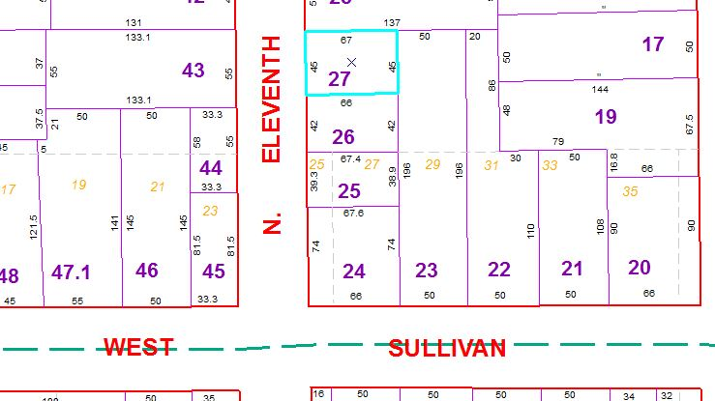
Approximate Yearly Taxes

School $871
City $491
County $464

Total $1,826

