Parcel 259

Middle Rd, Town of Machias
No Photo Available |  | Status: | Active
 |  | Roll Section: | Taxable
 |  | Swis: | 045800
 |  | Tax Map ID #: | 22.013-3-35
 |  | Account #: | 0464
 |  | Property Class: | 311 - Res vac land
 |  | Site: | RES 1
 |  | In Ag. District: | No
 |  | Site Property Class: | 311 - Res vac land
 |  | Zoning Code: | 01
 |  | Neighborhood Code: | 58050
Total Acreage/Size: | 100 x 75 | School District: | Yorkshire-Pioneer
Land Assessment: | 2016 - $4,200 | Total Assessment: | 2016 - $4,200
Full Market Value: | 2016 - $4,200
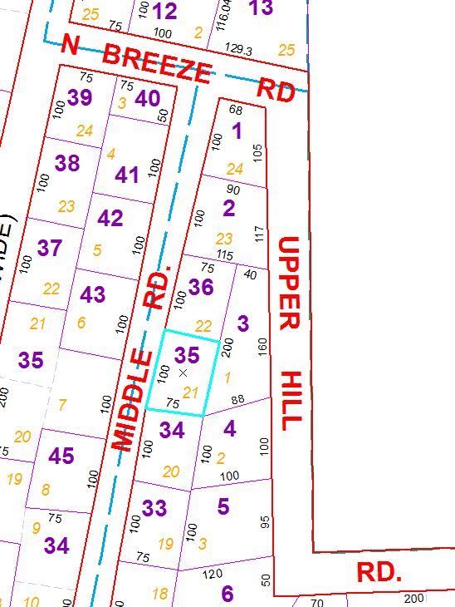
Approximate Yearly Taxes

School $60
Town/County $81

Total $141

