Parcel 24

754 Garden Ave, City of Olean
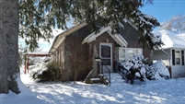 |  |  |  |  |  |  | Status: |  |  |  | Active
 |  |  |  |  |  |  | Roll Section: |  |  |  | Taxable
 |  |  |  |  |  |  | Swis: |  |  |  | 041200
 |  |  |  |  |  |  | Tax Map ID #: |  |  |  | 94.066-4-38
 |  |  |  |  |  |  | Account #: |  |  |  | 020175
 |  |  |  |  |  |  | Property Class: |  |  |  | 210 - 1 Family Res
 |  |  |  |  |  |  | Site: |  |  |  | RES 1
 |  |  |  |  |  |  | In Ag. District: |  |  |  | No
 |  |  |  |  |  |  | Site Property Class: |  |  |  | 210 - 1 Family Res
 |  |  |  |  |  |  | Zoning Code: |  |  |  | -
 |  |  |  |  |  |  | Neighborhood Code: |  |  |  | 12205
Total Acreage/Size: |  |  | 50 x 96 |  |  |  | School District: |  |  |  | Olean
Land Assessment: |  |  | 2016 - $4,200 |  |  |  | Total Assessment: |  |  |  | 2016 - $55,800
Full Market Value: |  |  | 2016 - $60,652
Living Area: |  | 1,120 sq. ft. |  |  | First Story Area: |  |  |  |  | 1,120 sq. ft.
Finished Basement: |  | 0 sq. ft. |  |  | Number of Stories: |  |  |  |  | 1
Building Style: |  | Bungalow |  |  | Bathrooms (Full - Half): |  |  |  |  | 1 - 0
Bedrooms: |  | 3 |  |  | Kitchens: |  |  |  |  | 1
Fireplaces: |  | 1 |  |  | Basement Type: |  |  |  |  | Full
Porch Type: |  | Porch-covered |  |  | Porch Area: |  |  |  |  | 30.00
Basement Garage Cap: |  | 0 |  |  | Attached Garage Cap: |  |  |  |  | 286.00 sq. ft.
Overall Condition: |  | Normal |  |  | Overall Grade: |  |  |  |  | Good
Year Built: |  | 1928
Structure | Size |  |  | Grade |  | Condition |  |  | Year
Porch-covered | 6 × 5 |  |  | Average |  | Normal |  |  | 1928
Porch-covered | 13 × 18 |  |  | Average |  | Normal |  |  | 1974
Gar-1.0 attached | 13 × 22 |  |  | Average |  | Normal |  |  | 1958
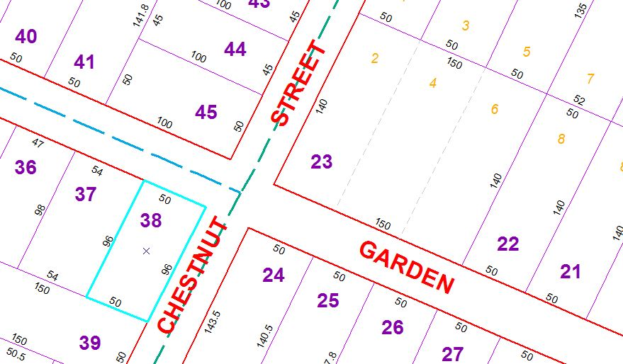
Approximate Yearly Taxes

School $1,430
City $805
County $761

Total $2,996

