Parcel 214

Wagner Hill Rd, Town of Hinsdale
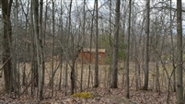 |  | Status: | Active
 |  | Roll Section: | Taxable
 |  | Swis: | 044600
 |  | Tax Map ID #: | 77.003-1-23.1
 |  | Account #: | 0573
 |  | Property Class: | 311 - Res vac land
 |  | Site: | RES 1
 |  | In Ag. District: | No
 |  | Site Property Class: | 311 - Res vac land
 |  | Zoning Code: | 01
 |  | Neighborhood Code: | 46200 - Secondary Roads
Total Acreage/Size: | 1.65 | School District: | Hinsdale
Land Assessment: | 2016 - $7,100 | Total Assessment: | 2016 - $7,100
Full Market Value: | 2016 - $8,068 | Approximate Yearly Taxes  School $121  Town/County $167  Total $288
