Parcel 212

1181 Congress Rd, Town of Hinsdale
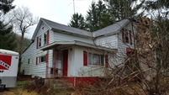 |  |  |  |  |  |  | Status: |  |  | Active
 |  |  |  |  |  |  | Roll Section: |  |  | Taxable
 |  |  |  |  |  |  | Swis: |  |  | 044600
 |  |  |  |  |  |  | Tax Map ID #: |  |  | 77.001-1-37
 |  |  |  |  |  |  | Account #: |  |  | 0763
 |  |  |  |  |  |  | Property Class: |  |  | 210 - 1 Family Res
 |  |  |  |  |  |  | Site: |  |  | RES 1
 |  |  |  |  |  |  | In Ag. District: |  |  | No
 |  |  |  |  |  |  | Site Property Class: |  |  | 210 - 1 Family Res
 |  |  |  |  |  |  | Zoning Code: |  |  | -
 |  |  |  |  |  |  | Neighborhood Code: |  |  | 46100 - Town Roads
Total Acreage/Size: |  |  | 1.45 |  |  |  | School District: |  |  | Hinsdale
Land Assessment: |  |  | 2016 - $8,400 |  |  |  | Total Assessment: |  |  | 2016 - $20,000
Full Market Value: |  |  | 2016 - $22,727
Living Area: |  | 1,399 sq. ft. |  |  | First Story Area: |  |  | 960 sq. ft.
Additional Story Area: |  | 0 sq. ft. |  |  | 3/4 Story Area: |  |  | 439 sq. ft.
Finished Basement: |  | 0 sq. ft. |  |  | Number of Stories: |  |  | 1.7
Building Style: |  | Old style |  |  | Bathrooms Full: |  |  | 1
Bedrooms: |  | 3 |  |  | Kitchens: |  |  | 1
Fireplaces: |  | 0 |  |  | Basement Type: |  |  | Partial
Porch Type: |  | Porch-covered |  |  | Porch Area: |  |  | 213.00
Overall Condition: |  | Poor |  |  | Overall Grade: |  |  | Minimum
Year Built: |  | 1900
Structure | Size |  |  | Grade |  | Condition |  |  | Year
Shed-machine | 14 × 20 |  |  | Economy |  | Poor |  |  | 1930
Porch-covered | 213 sq. ft. |  |  | Minimum |  | Poor |  |  | 1900
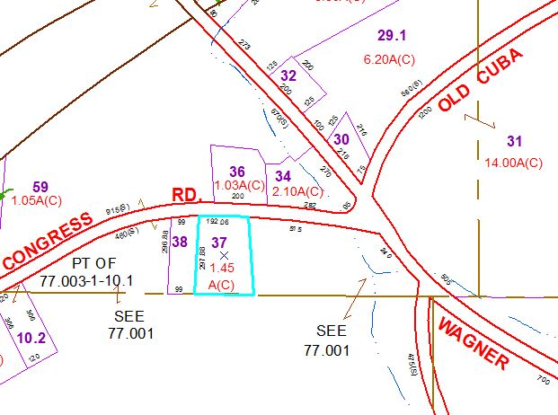
Approximate Yearly Taxes

School $340
Town/County $470

Total $810

