Parcel 21

1202 Sullivan St W, City of Olean
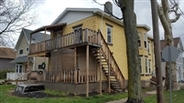 |  |  |  |  |  |  |  | Status: |  |  |  | Active
 |  |  |  |  |  |  |  | Roll Section: |  |  |  | Taxable
 |  |  |  |  |  |  |  | Swis: |  |  |  | 041200
 |  |  |  |  |  |  |  | Tax Map ID #: |  |  |  | 94.056-3-45
 |  |  |  |  |  |  |  | Account #: |  |  |  | 054300
 |  |  |  |  |  |  |  | Property Class: |  |  |  | 411 - Apartment
 |  |  |  |  |  |  |  | Site: |  |  |  | COM 1
 |  |  |  |  |  |  |  | In Ag. District: |  |  |  | No
 |  |  |  |  |  |  |  | Site Property Class: |  |  |  | 411 - Apartment
 |  |  |  |  |  |  |  | Zoning Code: |  |  |  | -
 |  |  |  |  |  |  |  | Neighborhood Code: |  |  |  | 12402
Total Acreage/Size: |  |  |  | 33.3 x 81.5 |  |  |  | School District: |  |  |  | Olean
Land Assessment: |  |  |  | 201 - $5,300 |  |  |  | Total Assessment: |  |  |  | 2016 - $64,000
Full Market Value: |  |  |  | 2016 - $69,565
AC% | Sprinkler% | Alarm% |  |  | Elevators |  | Basement Type |  | Year Built |  | Condition |  | Quality |  | Gross Floor Area (sq ft) |  |  | Stories
0 | 0 | 0 |  |  | 0 |  | Unfinished |  | 1906 |  | Normal |  | Average |  | 2511 |  |  | 2.00
Structure |  |  | Size |  |  | Grade |  |  |  | Condition |  |  |  | Year
Porch-up enclosed |  |  | 24 × 8 |  |  | Average |  |  |  | Normal |  |  |  | 1906
Porch-enclosed |  |  | 24 × 6 |  |  | Average |  |  |  | Normal |  |  |  | 1906
Porch-up open |  |  | 24 × 8 |  |  | Average |  |  |  | Good |  |  |  | 2010
Porch-covered |  |  | 24 × 8 |  |  | Average |  |  |  | Good |  |  |  | 2010
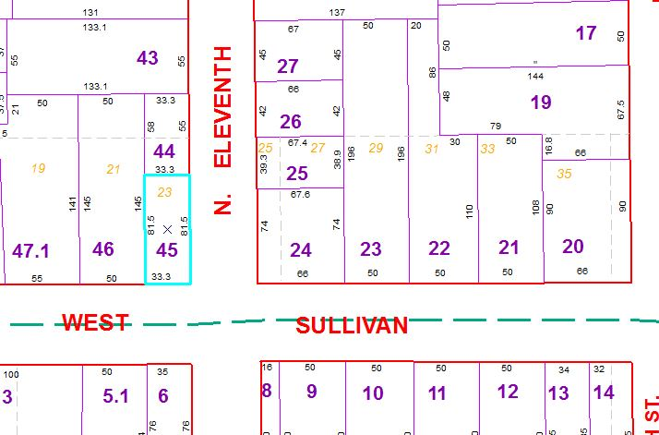
Approximate Yearly Taxes

School $1,640
City $923
County $873

Total $3,436

