Parcel 203

Union Valley Rd, Town of Hinsdale
No Photo Available |  | Status: | Active
 |  | Roll Section: | Taxable
 |  | Swis: | 044600
 |  | Tax Map ID #: | 85.002-2-25.1
 |  | Account #: | 0242
 |  | Property Class: | 322 - Rural vac>10
 |  | Site: | RES 1
 |  | In Ag. District: | No
 |  | Site Property Class: | 322 - Rural vac>10
 |  | Zoning Code: | -
 |  | Neighborhood Code: | 46100 - Town Roads
Total Acreage/Size: | 25.21 | School District: | Hinsdale
Land Assessment: | 2016 - $18,400 | Total Assessment: | 2016 - $18,400
Full Market Value: | 2016 - $20,909
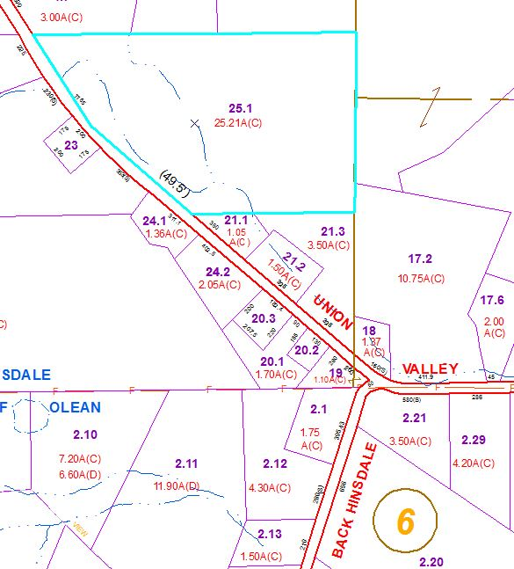
Approximate Yearly Taxes

School $313
Town/County $432

Total $745

