Parcel 199

Hedden Hollow Rd, Town of Hinsdale
No Photo Available |  | Status: | Active
 |  | Roll Section: | Taxable
 |  | Swis: | 044600
 |  | Tax Map ID #: | 77.004-3-13.1
 |  | Account #: | 0969
 |  | Property Class: | 314 - Rural vac<10
 |  | Site: | RES 1
 |  | In Ag. District: | No
 |  | Site Property Class: | 314 - Rural vac<10
 |  | Zoning Code: | -
 |  | Neighborhood Code: | 46100 - Town Roads
Total Acreage/Size: | 1.16 | School District: | Hinsdale
Land Assessment: | 2016 - $8,100 | Total Assessment: | 2016 - $8,100
Full Market Value: | 2016 - $9,205
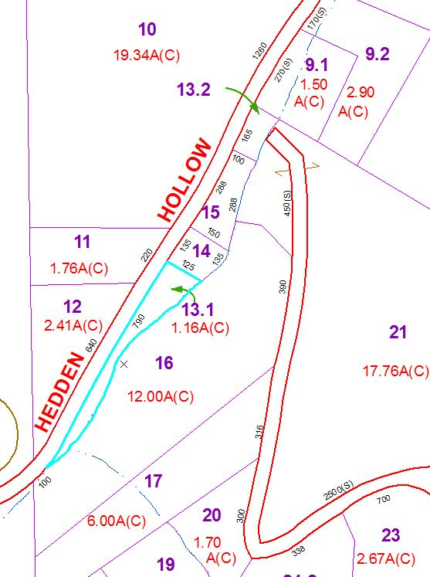
Approximate Yearly Taxes

School $138
Town/County $190

Total $328

