Parcel 187

11486 Rte 98, Town of Freedom
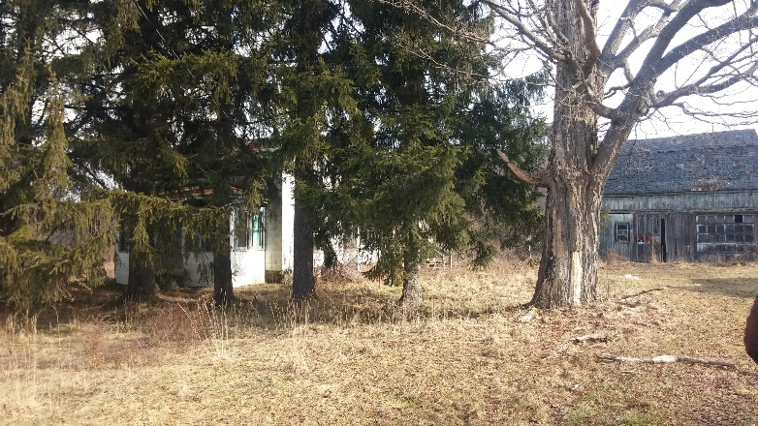 |  |  |  | Status: |  | Active
 |  |  |  | Roll Section: |  | Taxable
 |  |  |  | Swis: |  | 044200
 |  |  |  | Tax Map ID #: |  | 14.005-1-29
 |  |  |  | Account #: |  | 0549
 |  |  |  | Property Class: |  | 210 - 1 Family Res
 |  |  |  | Site: |  | RES 1
 |  |  |  | In Ag. District: |  | No
 |  |  |  | Site Property Class: |  | 210 - 1 Family Res
 |  |  |  | Zoning Code: |  | 01
 |  |  |  | Neighborhood Code: |  | 04200 - Freedom
Total Acreage/Size: |  | 9.19 |  | School District: |  | Yorkshire-Pioneer
Land Assessment: |  | 2016 - $20,300 |  | Total Assessment: |  | 2016 - $79,500
Full Market Value: |  | 2016 - $79,500
Living Area: |  | 1,938 sq. ft. |  | First Story Area: |  | 1,292 sq. ft.
Second Story Area: |  | 0 sq. ft. |  | Half Story Area: |  | 646 sq. ft.
Finished Basement: |  | 0 sq. ft. |  | Number of Stories: |  | 1.5
Building Style: |  | Old style |  | Bathrooms Full |  | 1
Bedrooms: |  | 3 |  | Kitchens: |  | 1
Fireplaces: |  | 0 |  | Basement Type: |  | Crawl
Porch Type: |  | Porch-enclosed |  | Porch Area: |  | 120.00
Overall Condition: |  | Fair |  | Overall Grade: |  | Economy
Year Built: |  | 1900
Structure | Size |  | Grade |  | Condition |  | Year
Shed-machine | 12 × 13 |  | Economy |  | Fair |  | 1920
Gar-1.0 detached | 19 × 25 |  | Minimum |  | Fair |  | 1920
Shed-machine | 19 × 26 |  | Economy |  | Fair |  | 1920
Shed-machine | 12 × 14 |  | Economy |  | Fair |  | 1920
Shed-machine | 10 x 14 |  | Economy |  | Fair |  | 1920
Shed-machine | 15 x 38 |  | Economy |  | Fair |  | 1920
Barn-2.0 gen | 25 x 33 |  | Economy |  | Fair |  | 1920
Porch-enclosed | 20 x 6 |  | Average |  | Normal |  | 1900
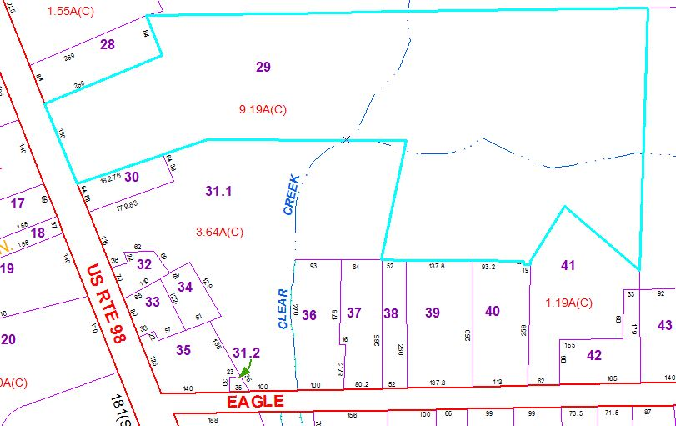
Approximate Yearly Taxes

School $1,108
Town/County $1,427

Total $2,535

