Parcel 165

10 Factory St, V. Franklinville
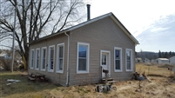 |  |  |  | Status: |  | Active
 |  |  |  | Roll Section: |  | Taxable
 |  |  |  | Swis: |  | 044001
 |  |  |  | Tax Map ID #: |  | 40.070-2-6
 |  |  |  | Account #: |  | 0792
 |  |  |  | Property Class: |  | 210 - 1 Family Res
 |  |  |  | Site: |  | RES 1
 |  |  |  | In Ag. District: |  | No
 |  |  |  | Site Property Class: |  | 210 - 1 Family Res
 |  |  |  | Zoning Code: |  | 1030
 |  |  |  | Neighborhood Code: |  | 40150
Total Acreage/Size: |  | 47.36 x 75.77 |  | School District: |  | Franklinville
Land Assessment: |  | 2016 - $4,000 |  | Total Assessment: |  | 2016 - $7,800
Full Market Value: |  | 2016 - $11,143
Living Area: | 837 sq. ft. |  | First Story Area: |  | 837 sq. ft.
Second Story Area: | 0 sq. ft. |  | Half Story Area: |  | 418 sq. ft.
Finished Basement: | 0 sq. ft. |  | Number of Stories: |  | 1.5
Building Style: | Old style |  | Bathrooms (Full - Half): |  | 1 - 0
Bedrooms: | 2 |  | Kitchens: |  | 1
Fireplaces: | 0 |  | Basement Type: |  | Crawl
Overall Condition: | Fair |  | Overall Grade: |  | Economy
Year Built: | 1920
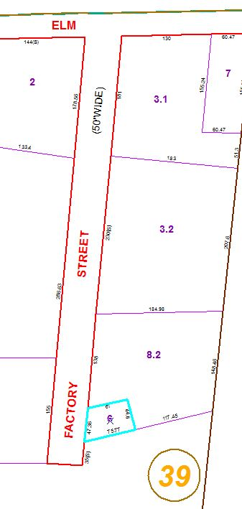
Approximate Yearly Taxes

School $204
Village $102
Town/County $227

Total $533

