Parcel 141

Fancy Tract Rd, Town of Ellicottville
No Photo Available |  | Status: | Active
 |  | Roll Section: | Taxable
 |  | Swis: | 043689
 |  | Tax Map ID #: | 38.004-1-18.3
 |  | Account #: | 1444
 |  | Property Class: | 314 - Rural vac<10
 |  | Site: | RES 1
 |  | In Ag. District: | No
 |  | Site Property Class: | 314 - Rural vac<10
 |  | Zoning Code: | 04
 |  | Neighborhood Code: | 36030 - West Valley School
Total Acreage/Size: | 15 x 160 | School District: | West Valley
Land Assessment: | 2016 - $1,200 | Total Assessment: | 2016 - $1,200
Full Market Value: | 2016 - $1,200
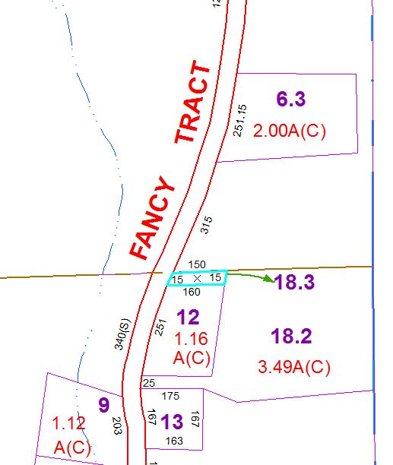
Approximate Yearly Taxes

School $28
Town/County $18

Total $46

