Parcel 122

108 Mill St, V. South Dayton
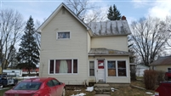 |  |  |  |  |  |  | Status: |  |  |  | Active
 |  |  |  |  |  |  | Roll Section: |  |  |  | Taxable
 |  |  |  |  |  |  | Swis: |  |  |  | 043001
 |  |  |  |  |  |  | Tax Map ID #: |  |  |  | 33.034-3-12
 |  |  |  |  |  |  | Account #: |  |  |  | 0724
 |  |  |  |  |  |  | Property Class: |  |  |  | 210 - 1 Family Res
 |  |  |  |  |  |  | Site: |  |  |  | RES 1
 |  |  |  |  |  |  | In Ag. District: |  |  |  | No
 |  |  |  |  |  |  | Site Property Class: |  |  |  | 210 - 1 Family Res
 |  |  |  |  |  |  | Zoning Code: |  |  |  | -
 |  |  |  |  |  |  | Neighborhood Code: |  |  |  | 30080
Total Acreage/Size: |  |  | 64 x 125 |  |  |  | School District: |  |  |  | Pine Valley
Land Assessment: |  |  | 2016 - $3,000 |  |  |  | Total Assessment: |  |  |  | 2016 - $40,400
Full Market Value: |  |  | 2016 - $40,400
Living Area: |  | 942 sq. ft. |  |  | First Story Area: |  |  |  |  | 724 sq. ft.
Second Story Area: |  | 0 sq. ft. |  |  | Half Story Area: |  |  |  |  | 218 sq. ft.
Finished Basement: |  | 0 sq. ft. |  |  | Number of Stories: |  |  |  |  | 1.5
Building Style: |  | Old style |  |  | Bathrooms (Full - Half): |  |  |  |  | 1 - 0
Bedrooms: |  | 3 |  |  | Kitchens: |  |  |  |  | 1
Fireplaces: |  | 0 |  |  | Basement Type: |  |  |  |  | Partial
Porch Type: |  | Porch-enclosed |  |  | Porch Area: |  |  |  |  | 110.00
Overall Condition: |  | Normal |  |  | Overall Grade: |  |  |  |  | Average
Year Built: |  | 1940
Structure | Size |  |  | Grade |  | Condition |  |  | Year
Porch-enclosed | 11 × 10 |  |  | Average |  | Normal |  |  | 1982
Porch-covered | 15 × 8 |  |  | Minimum |  | Normal |  |  | 1982
Porch-enclosed | 11 × 7 |  |  | Average |  | Normal |  |  | 1982
Gar-2.0 detached | 24 × 40 |  |  | Minimum |  | Fair |  |  | 1900
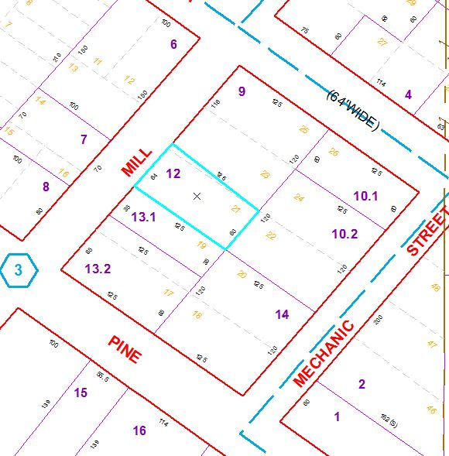
Approximate Yearly Taxes

School $ 670
Village $ 377
Town/County $ 760

Total $1,807

