Parcel 118

James Rd, Town of Dayton
No Photo Available |  | Status: | Active
 |  | Roll Section: | Taxable
 |  | Swis: | 043089
 |  | Tax Map ID #: | 16.004-1-46.3
 |  | Account #: | 0239
 |  | Property Class: | 311 - Res vac land
 |  | Site: | RES 1
 |  | In Ag. District: | No
 |  | Site Property Class: | 311 - Res vac land
 |  | Zoning Code: | -
 |  | Neighborhood Code: | 30050
Total Acreage/Size: | 1.15 | School District: | Gowanda
Land Assessment: | 2016 - $1,200 | Total Assessment: | 2016 - $1,200
Full Market Value: | 2016 - $1,200
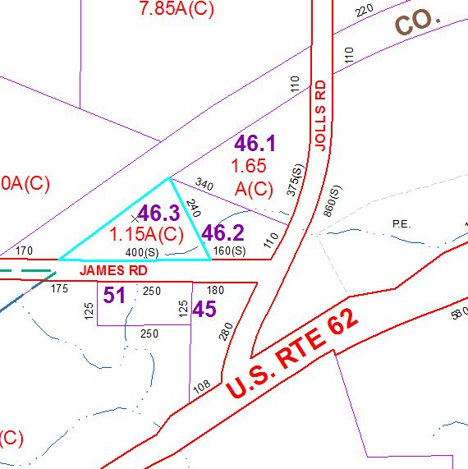
Approximate Yearly Taxes

School $30
Town/County $30

Total $60

