Parcel 105

3184 NYS 394 Rte., Town of Cold Spring
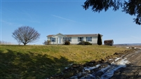 |  |  |  |  |  |  | Status: |  |  | Active
 |  |  |  |  |  |  | Roll Section: |  |  | Taxable
 |  |  |  |  |  |  | Swis: |  |  | 042600
 |  |  |  |  |  |  | Tax Map ID #: |  |  | 80.001-1-9.2
 |  |  |  |  |  |  | Account #: |  |  | 5016
 |  |  |  |  |  |  | Property Class: |  |  | 210 - 1 Family Res
 |  |  |  |  |  |  | Site: |  |  | RES 1
 |  |  |  |  |  |  | In Ag. District: |  |  | No
 |  |  |  |  |  |  | Site Property Class: |  |  | 210 - 1 Family Res
 |  |  |  |  |  |  | Zoning Code: |  |  | 01
 |  |  |  |  |  |  | Neighborhood Code: |  |  | 26050
Total Acreage/Size: |  |  | 160 x 247.5 |  |  |  | School District: |  |  | Randolph
Land Assessment: |  |  | 2016 - $6,700 |  |  |  | Total Assessment: |  |  | 2016 - $91,700
Full Market Value: |  |  | 2016 - $91,700
Building Style: |  | Ranch |  |  | Bathrooms |  |  | 2 - 0
Bedrooms: |  | 3 |  |  | Kitchens: |  |  | 1
Fireplaces: |  | 0 |  |  | Basement Type: |  |  | Crawl
Basement Garage Cap: |  | 0 |  |  | Attached Garage Cap: |  |  | 676.00 sq. ft.
Year Built: |  | 2000
Structure |  | Size |  |  | Grade |  |  | Condition
Gar-1.0 attached |  | 26 × 26 |  |  | Average |  |  | Normal
Porch-up covered |  | 4 × 8 |  | Average |  | Fair |  |  | Year
Porch-covered |  | 5 × 12 |  | Average |  | Poor |  |  | 1989
Milk house |  | 16 × 18 |  | Economy |  | Fair |  |  | 1910
Barn-2.0 dairy |  | 0 x 0 |  | Economy |  | Poor |  |  | 1910
Shed-machine |  | 20 x 20 |  | Economy |  | Poor |  |  | 1960
Quonset hut |  | 0 x 0 |  | Economy |  | Fair |  |  | 1890
Silo-con stv |  | 60 x 20 |  | Economy |  | Fair |  |  | 1980
Barn-2.0 gen |  | 0 x 0 |  | Economy |  | Fair |  |  | 1955
Barn-pole |  | 36 x 62 |  | Economy |  | Normal |  |  | 1965
Porch-open/deck |  | 0 x 0 |  | Average |  | Normal |  |  | 1940
Pool-above grn |  | 0 x 0 |  | Economy |  | Normal |  |  | 1984
Porch-open/deck |  | 0 x 0 |  | Average |  | Normal |  |  | 1920
Shed-galvanized |  | 15 x 30 |  | Economy |  | Normal |  |  | 2001
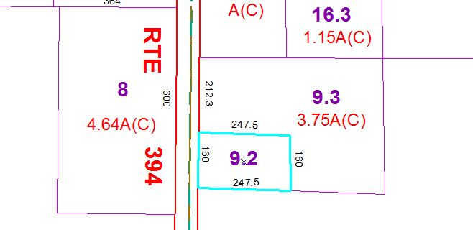
Approximate Yearly Taxes

School $1,019
Town/County $1,462

Total $2,481

